Pelvic anatomy

True pelvis and false pelvis

False pelvis
Part of the pelvis above the linea terminalis is false pelvis
Boundaries
- Posteriorly - lumbar vertebra
- Laterally - iliac fossa
- Anteriorly - lower abdominal wall

True pelvis
Boundaries
- Anteriorly - upper margin of pubis
- Laterally - linea terminalis
- Posteriorly - sacral promontory and alae of sacrum

Linea terminalis
Innominate line Consists of
- Pectineal line (pecten pubis)
- Arcuate line
- Pubic crest
- Sacral ala, and
- Sacral promontory
It forms the boundary of the pelvic inlet

Cavity of true pelvis
Cavity of true pelvis is bent anteriorly
Posterior wall is ~ 10 cm and anterior wall ~5 cm

Walls of the true pelvis
Posterior boundary - sacrum
Lateral walls - inner surface of the ischial bones and the Sacro sciatic notches and ligaments
Anterior boundary - pubic bones, the ascending superior rami of the ischial bones, and the obturator foramen
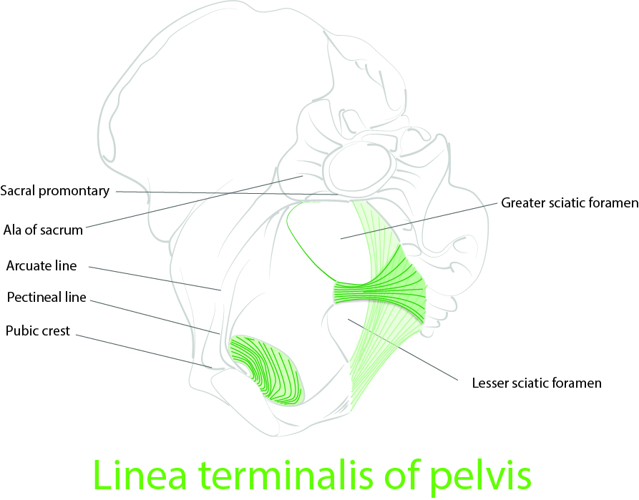
Linea terminalis - pelvic brim, edge of pelvic inlet

Diameters

Shortest diameter of the pelvic cavity
Shortest diameter of the pelvic cavity - distance between the ischial spines
Ischial spines - landmark for assessing the level to which the presenting part of the foetus during labour

Pubic arch
Inferior rami of the pubic bones - forms 90 to 110 round arch

Pelvic joints

Symphysis pubis
- Joint in the midline between two pubic bones
- Consists of fibrocartilage and superior + inferior pubic ligaments
- Arcuate ligament of the pubis = inferior pubic ligament

Sacroiliac Joints
- Joint between the sacrum and the iliac portion of the pelvic bones
- Movements - Nutation and ante-nutation
Joints are relaxed by relaxin

Pelvic planes and diameters
- Pelvic Inlet
- Mid pelvis
- Pelvic Outlet

Pelvic Inlet

Boundaries
- Posterior - promontory and alae of the sacrum
- Lateral - linea terminalis
- Anterior - horizontal pubic rami and the symphysis pubis

Diameters of the pelvic inlet

Anteroposterior diameter
- Shortest distance between the promontory of the sacrum and the symphysis pubis
- Also referred as obstetrical conjugate
- Obstetrically most important

Transverse diameter
- Greatest distance between the linea terminalis on either side
- Constructed at right angles to the anteroposterior diameter

Two oblique diameters
- From one of the sacroiliac synchondroses to the iliopectineal eminence on the opposite side

Obstetrical conjugate
Shortest anteroposterior diameter through which the head must pass in descending through the pelvic inlet. Obstetrical conjugate cannot be measured directly

Diagonal conjugate
Distance from the lower margin of the symphysis to the promontory of the sacrum

Measurement
Diagonal conjugate is measured through per-vaginal examination.
Coccyx mobility is examined and later sacrum is palpated from below upwards.
Usually, only the last three sacral vertebrae can be felt without indenting the perineum
Obstetrical conjugate is computed by subtracting 1.5 to 2.0 cm

True conjugate
The anteroposterior diameter of the pelvic inlet
It is not the shortest diameter of the pelvic inlet

Midpelvis
Plane of least pelvic dimensions
Measured at the level of the ischial spines
Interspinous diameter is usually the smallest diameter of the pelvis

Pelvic Outlet
Has two triangles facing opposite directions with a common base
Posterior apex - tip of sacrum
Lateral - sacrosciatic ligaments and the ischial tuberosities
Anterior - pubic arch

Pelvic shapes
- Gynecoid
- Anthropoid
- Anthropoid
- Platypelloid
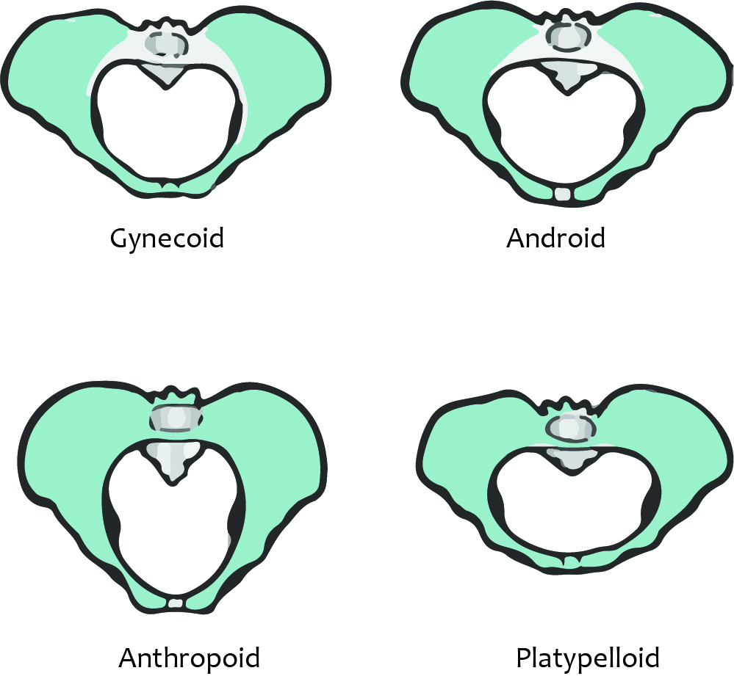

Engagement
Descent of the biparietal plane of the fetal head to a level below that of the pelvic inlet
Once, the fetal head engages, it proves that the pelvic inlet is ample for that foetus

Clinical importance
- Women with the wider pelvis and a shorter obstetric conjugate are found to be associated with increased risk of pelvic floor disorders later in life.
- These women often have difficult labour that predisposes them to development of pelvic floor neuropathy or pelvic floor prolapse.

Surgically important ligaments

Sacrospinous Ligament
- Extends from the ischial spine to sacrum
- Pudendal nerve and internal pudendal nerves pass deep to this ligament
- Clinical importance: sacrospinous ligament is used for the vaginal suspension

Sacrotuberous Ligament
- Extends from ischial tuberosity to lateral aspect of the sacrum
- Merges medially with the sacrospinous ligament
- Pudendal nerve and internal pudendal vessels lie anterior to the sacrospinous ligament

Foramina

Greater sciatic foramen
- Structures passing through the greater sciatic foramen are
- Piriformis
- Superior gluteal nerves and vessels
- Sciatic nerve
- Nerve to obturator internus
- Internal pudendal nerve and vessels

Lesser sciatic foramen
- Structures passing through this foramen are
- Tendon of obturator internus
- Nerve to obturator internus
- Pudendal vessels and nerve reenter pelvis

Muscles of pelvis

Lateral pelvic wall muscles
- Piriformis
- Obturator internus
- Iliopsoas

Pelvic floor muscles
- Pelvic diaphragm
- levator ani and the coccygeus muscles
- superior and inferior fasciae
